SQT UNIT-3
Q1) What is Boundary Value Analysis (BVA) in software testing, and what is its primary objective? And why is BVA considered an effective test design technique?
A)
Boundary Value Analysis (BVA) — definition, objective & why it works
Boundary Value Analysis (BVA) is a black-box test-design technique that focuses on the edges (boundaries) of input domains. Instead of trying every possible input, BVA targets values at, just below, and just above the boundary limits of an input range because defects are disproportionately likely to occur there.
Primary objective
The main goal of BVA is to find defects that occur at the boundaries of input domains — e.g., off-by-one errors, incorrect inequality handling (<= versus <), improper input validation, and similar edge-case faults — with a small, focused set of test cases.
BVA working (step-by-step)
- Identify input variables with defined ranges or partitions (numeric ranges, string lengths, date ranges, array indices, etc.).
- For each variable, determine its valid domain: minimum (Min) and maximum (Max).
- Select boundary test values: typical choices are
  - Min
  - Min + 1
  - Max − 1
  - Max
Optionally (robust BVA): include invalid values just outside the domain — Min − 1 and Max + 1.
- Create test cases using these boundary values. For multiple variables, use a manageable combination strategy (e.g., vary one variable at a time, pairwise combinations) to avoid explosion.
- Run tests and check expected behaviour (pass/fail, error messages, boundary handling).
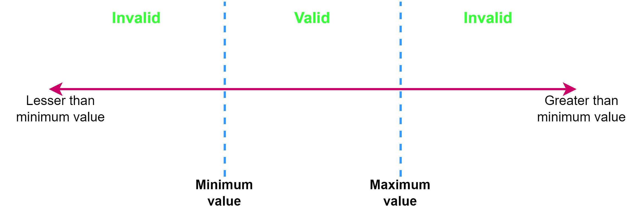
Concrete example
Requirement: Input field accepts integers from 1 to 100 inclusive.
Recommended BVA test values (robust version):
0 (Min−1), 1 (Min), 2 (Min+1), 99 (Max−1), 100 (Max), 101 (Max+1)
Test Value | Expected Result
0 | Reject / error
1 | Accept
2 | Accept
99 | Accept
100 | Accept
101 | Reject / error
This quickly exposes off-by-one and improper boundary checks.
Why BVA is effective
- Defects cluster at edges: Empirical studies and practitioner experience show many bugs occur at boundary conditions (off-by-one, incorrect comparisons, overflow).
- High fault-finding efficiency: Testing a few boundary values often uncovers defects that many random tests miss.
- Low test count, high yield: Gives good defect detection with far fewer tests than exhaustive testing.
- Easy to apply: Conceptually simple and quick to design; works across numeric, length, date, index, and many other domains.
- Complements other techniques: Works very well with Equivalence Partitioning (EP): EP defines partitions; BVA tests their edges.
Variants & extensions
- Robust BVA: Includes out-of-range values (Min−1, Max+1) to verify rejection/validation behavior.
- Multi-variable BVA: For systems with multiple inputs, vary one boundary at a time or use pairwise/orthogonal combination to keep tests practical.
- Type/system limits: Consider language/system boundaries (e.g., integer min/max, buffer sizes, encoding limits).
Limitations
- Not sufficient alone: BVA focuses on edges; bugs deep inside the domain or caused by specific value combinations may be missed. Combine with EP, state-transition, decision-table, and other techniques.
- Combinatorial explosion: Naively applying BVA across many inputs leads to many combinations — use smart combination strategies (pairwise, orthogonal arrays).
- Non-numeric domains require mapping: You must map meaningful boundaries for strings, enums, collections, or GUIs (e.g., min/max length, first/last enum value).

Q2) What are the main limitations or challenges when using Boundary Value Analysis? And when would you typically apply BVA during the testing process?
A)
1. Limitations / Challenges of Boundary Value Analysis (BVA)
Although BVA is powerful and widely used, it has several practical limitations:
a) Only focuses on boundaries, not the entire domain
- BVA tests input values at the edges of valid/invalid partitions.
- Errors that occur inside the partitions (not near boundaries) may go undetected.
- Example: If the valid range is 1–100, a defect at value 50 will not be caught by BVA.
b) Limited with non-numeric or categorical inputs
- BVA works best with ordered, continuous domains (numbers, ranges, lengths).
- For categorical values (e.g., colors: Red, Blue, Green), there are no natural boundaries, so BVA becomes less useful.
c) Explosion of test cases in multi-variable systems
- For multiple input fields, applying BVA to every boundary combination leads to a combinatorial explosion.
- Example: For 3 inputs, each with 6 BVA test values, total = 6³ = 216 tests. This is impractical.
- Testers need to balance thoroughness with feasibility, often using pairwise testing.
d) Doesn’t address sequence- or state-based issues
- BVA checks static input boundaries, but it doesn’t handle workflow, state transitions, or order of operations.
- Bugs caused by wrong state changes, invalid transitions, or timing won’t be found.
e) May miss integration/system-level defects
- BVA is typically applied at the unit or component level.
- At higher levels (integration, system), defects may not be boundary-related (e.g., performance bottlenecks, UI issues).
f) Assumes well-defined input ranges
- To apply BVA effectively, the input domain must be known and documented.
- In poorly specified requirements, unclear boundaries make BVA difficult or ambiguous.
g) Risk of over-reliance
- Testers might think BVA is “enough” since it’s systematic and efficient.
- But relying solely on BVA can leave logic errors, business rules, and non-functional issues untested.



2. When to Apply BVA in the Testing Process
BVA is generally applied in early test design stages and used throughout the testing lifecycle in specific contexts:
a) During Test Design (Requirement Analysis / Design Stage)
- Right after requirements are clear and equivalence partitions are identified.
- BVA is applied to define critical edge test cases.
- Example: In requirements saying “input accepts 1–100”, testers immediately derive BVA cases (0, 1, 2, 99, 100, 101).
b) During Unit Testing
- Developers use BVA to check boundary conditions of functions/methods.
- Example: Testing array indices at 0, 1, n−1, n.
c) During System and Integration Testing
- To validate that data flows correctly across modules and boundaries are enforced consistently.
- Example: If system A outputs max 255 but system B only accepts up to 200, BVA detects integration issues.
d) During Validation / Acceptance Testing
- BVA helps confirm that the application correctly handles edge scenarios that real users are most likely to encounter.
- Example: A form field that accepts up to 50 characters must be tested with 49, 50, and 51 characters.

Q3) What is Equivalence Partitioning (EP) in software testing, and what is its primary goal? And how does Equivalence Partitioning complement Boundary Value Analysis (BVA)?
A)
Equivalence Partitioning (EP) — definition & primary goal
What it is:
Equivalence Partitioning (aka Equivalence Class Testing) is a black-box test-design technique that divides an input domain into partitions (equivalence classes) where the system is expected to behave the same for every value in the same partition. Instead of testing every possible input, you pick one representative value from each partition.
Primary goal:
To reduce the number of test cases while preserving fault detection capability by choosing representative values from each logically equivalent class (valid and invalid). In short: cover many inputs with a few well-chosen tests.
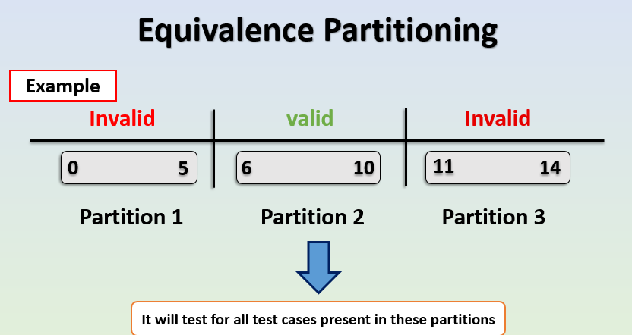
How EP works (practical steps)
- Identify each input (fields, parameters, file contents, etc.).
- For each input, determine partitions — e.g., valid ranges, invalid ranges, special values, empty vs non-empty, enumerations, etc.
- Label partitions as valid or invalid.
- Choose a representative value from each partition. (One test per partition; more if needed for coverage.)
- Combine representatives across inputs into test cases (use combination strategies like one-at-a-time, pairwise, or orthogonal arrays to avoid explosion).
- Define expected results for each test case and execute.

Simple numeric example
Requirement: input accepts integers from 1 to 100 inclusive.
Partitions:
- Invalid Low: x < 1
- Valid: 1 ≤ x ≤ 100
- Invalid High: x > 100
EP test cases would use these representatives — e.g., test with 0, 50, and 101.
How EP complements Boundary Value Analysis (BVA)
- EP chooses representatives from whole partitions (e.g., 50 for 1–100). EP is about coverage across categories.
- BVA zooms in on the edges of partitions (e.g., 1, 2, 99, 100 and possibly 0, 101). BVA is about edge correctness.
Together:
- EP ensures you exercise every logical category (valid/invalid/empty/special).
- BVA ensures you verify the exact boundary handling where many defects occur (off-by-one, incorrect comparisons).
Example (combined):
Partition (EP) | EP rep | BVA related values
Invalid Low | 0 | 0, 1, 2
Valid | 50 | 1, 2, 99, 100 (boundaries chosen by BVA)
Invalid High | 101 | 99, 100, 101
Use EP to identify the partitions and pick a middle representative; then use BVA on those partitions’ boundaries. This gives both breadth (EP) and depth at risky points (BVA).
Benefits of using EP
- Reduces test count dramatically vs. exhaustive testing.
- Systematic and easy to explain to stakeholders.
- Works for many input types: numbers, string lengths, date ranges, file sizes, enums (treat each enum as a partition).
- Plays well with other techniques (BVA, pairwise, decision tables).

Limitations / caveats
- Assumes uniform behavior inside a partition. If the system treats different values inside a partition differently, EP can miss defects.
- Not useful for unordered categorical data when no “equivalence” logic exists.
- Combination explosion when multiple inputs are present; you still need smart combination strategies.
- Relies on clear requirements. Poorly defined domains make partitioning ambiguous.
- May miss boundary defects if the chosen representative is not near the boundary — that’s why combine EP with BVA.

When to apply EP
- During test design / requirements analysis — once you know valid ranges and constraints.
- At unit, integration, system, and acceptance testing — anywhere inputs are validated or processed.
- Use EP as a first pass to create a compact set of tests, and then augment with BVA and other techniques where needed.

4) What is Decision Table Testing, and when is it particularly useful? And what are the main components of a Decision Table? Explain each briefly.
A)
Decision Table Testing:
Decision Table Testing is a black-box test design technique that uses a tabular representation of inputs (conditions) and their corresponding system behaviors (actions) to design effective test cases.
It is particularly useful when the system’s behavior depends on combinations of inputs or business rules.
The decision table provides a systematic way to ensure all possible conditions and their effects are covered, avoiding missed scenarios.
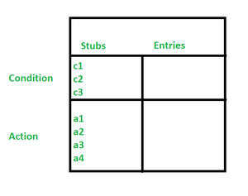

2. When is it particularly useful?
Decision Table Testing is most effective when:
- Multiple conditions influence the outcome (complex business rules).
- You want to ensure all possible combinations of inputs are tested.
- The system behavior is based on logical decisions (Yes/No, True/False, On/Off).
- There’s a risk of missing interactions if you test conditions independently.
Example: Loan approval depends on (1) Applicant income, (2) Credit score, and (3) Employment status. Each combination may lead to different outcomes (approve/reject/review). A decision table ensures all rule combinations are tested.

3. Main Components of a Decision Table
A decision table is usually structured into four quadrants:
a) Conditions Stub
- Definition: Lists all the input conditions or decision factors that affect the outcome.
- Purpose: Identifies what variables the decision depends on.
- Example:
  - Age of customer
  - Credit score
  - Account balance

b) Condition Entries
- Definition: Shows the possible values of each condition (often Yes/No, True/False, ranges, or enumerations).
- Purpose: Enumerates how each condition can vary.
- Example:
  - Age > 18 → Yes/No
  - Credit score ≥ 700 → Yes/No
  - Balance > 0 → Yes/No
c) Actions Stub
- Definition: Lists all the possible outcomes or actions the system should take, based on condition combinations.
- Purpose: Defines what the system must do for each decision rule.
- Example:
  - Approve loan
  - Reject loan
  - Request additional documents
d) Action Entries (Rules)
- Definition: Specify which action(s) are triggered for each possible combination of condition entries.
- Purpose: Provide the mapping between conditions and actions (the “rules” of the decision).
- Example Rule:
  - If (Age > 18 = Yes) AND (Credit Score ≥ 700 = Yes) → Action = Approve Loan
  - If (Age > 18 = No) OR (Credit Score ≥ 700 = No) → Action = Reject Loan

4. Simple Example Decision Table
Requirement: Bank approves a credit card if
- The applicant is over 18, and
- Has a good credit score (≥ 700).

Conditions | Rule 1 | Rule 2 | Rule 3 | Rule 4
Age > 18? | Y | Y | N | N
Credit score ≥ 700? | Y | N | Y | N
Actions
Approve credit card | ✔
Reject credit card |  | ✔ | ✔ | ✔
- Rule 1 → Approve (both conditions true)
- Rules 2, 3, 4 → Reject (at least one condition false)
This ensures all combinations are tested.

Q5) What is State Transition Testing, and when is it most applicable and its advantages?
A)
1. What is State Transition Testing?
State Transition Testing (STT) is a black-box test design technique used when the behavior of a system depends on its current state and on events or inputs that trigger transitions between states.
- The system is modeled as a State Machine, with states, transitions, events, and actions.
- Tests are designed to cover valid transitions, invalid transitions, and sequences of states.
In simple terms: You test how the system moves from one state to another based on input, and whether it produces the correct output.
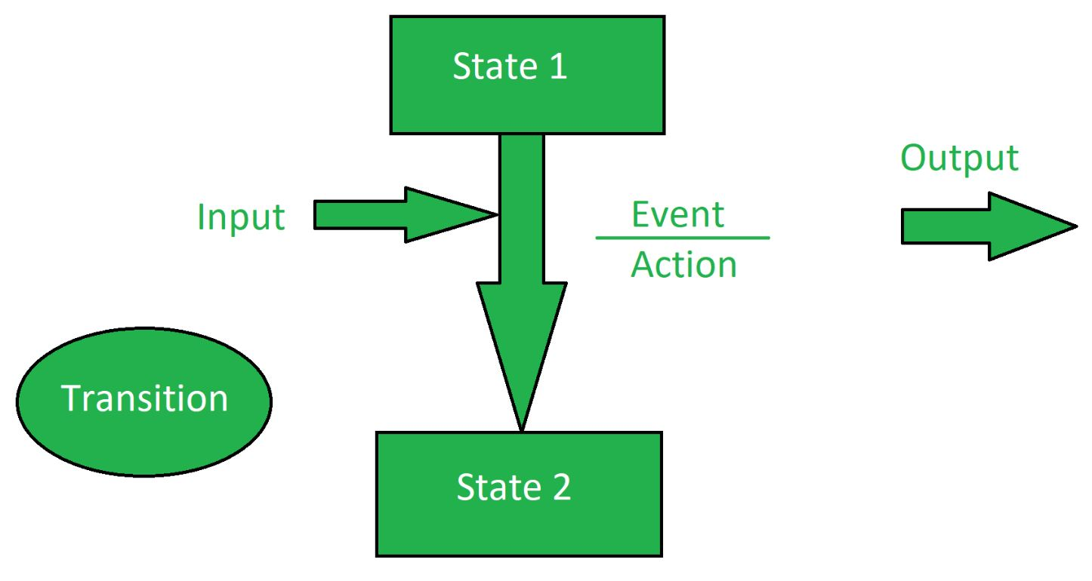
2. When is it most applicable?
State Transition Testing is particularly useful when:
- The system has finite, well-defined states.
- The output or behavior depends on history (previous states), not just current inputs.
- There are rules about which state transitions are valid or invalid.
- You need to test sequences of actions and not just single inputs.
Typical examples:
- Login system (states: Logged out → Logged in → Locked).
- ATM machine (states: Idle → Card inserted → PIN entered → Transaction).
- Traffic light system (states: Red → Green → Yellow → Red).
- Order processing system (states: Created → Paid → Shipped → Delivered).

3. Components of State Transition Testing
- States → Conditions or modes in which the system can exist.
- Transitions → Valid moves from one state to another based on an input/event.
- Events/Inputs → The triggers that cause transitions.
- Actions/Outputs → The response or result of a transition.

4. Example
ATM PIN validation system:
- User has 3 attempts to enter a correct PIN.
- States:
  - Idle → waiting for input
  - Active → card in, PIN attempts ongoing
  - Locked → after 3 wrong attempts
Transitions:
- Idle → Active (Insert card)
- Active → Idle (Correct PIN)
- Active → Locked (3 wrong attempts)
Tests would include:
- Valid transition (Insert card → enter correct PIN → access granted).
- Invalid transition (Try entering PIN without inserting card).
- Error handling (3 wrong attempts → Locked).

5. Advantages of State Transition Testing
a) Ensures thorough coverage of dynamic behavior
- Captures how the system behaves across different states and sequences, not just individual inputs.
b) Detects defects related to history and state handling
- Finds issues like:
  - Incorrect state change (e.g., allowing withdrawal without authentication).
  - Missing transitions (e.g., system stuck in a state).
  - Invalid transitions accepted incorrectly.
c) Provides a clear, structured model
- State diagrams/tables are easy to visualize and explain to stakeholders.
- Makes complex rules more understandable.
d) Effective for real-world reactive systems
- Many critical systems (banking, telecom, embedded systems) rely on stateful behavior. STT matches naturally with their design.
e) Supports both positive and negative testing
- Positive: Verify valid transitions work correctly.
- Negative: Verify invalid transitions are rejected.

Q6) What are the key components of a State Transition Diagram, which is often used in State Transition Testing?
A)
Key Components of a State Transition Diagram
A State Transition Diagram (STD) is a visual representation of how a system moves between different states in response to events/inputs and what actions/outputs occur as a result. It is often used in State Transition Testing (STT) to design effective test cases.
The main components are:
1. States
- Definition: A state is a specific condition, mode, or situation in which the system exists at a given time.
- Representation: Usually drawn as rectangles or rounded boxes.
- Examples:
  - “Logged Out”
  - “Logged In”
  - “Locked”
In testing, states define what the system currently is before an event occurs.

2. Transitions
- Definition: A transition is the movement from one state to another triggered by an event or input.
- Representation: Shown as arrows connecting states.
- Examples:
  - From “Logged Out” → “Logged In” when the correct password is entered.
  - From “Active” → “Locked” after 3 wrong PIN attempts.
Transitions define how the system changes state based on events.

3. Events / Inputs
- Definition: An event (or input) is the trigger that causes a state transition.
- Representation: Written on the transition arrow (sometimes with conditions).
- Examples:
  - “Enter correct PIN”
  - “Enter wrong password”
  - “Insert card”
Events are causes, and transitions are the effects.

4. Actions / Outputs
- Definition: An action (or output) is the result or behavior the system performs when a transition occurs.
- Representation: Shown along with the transition label, often in the form event / action.
- Examples:
  - Enter correct PIN / Access granted
  - 3 wrong attempts / Account locked
Actions describe what the system does in response to an event while moving states.

5. Initial State
- Definition: The starting point of the system before any event occurs.
- Representation: A filled black circle (●) pointing to the first state.
- Example:
  - For a login system, the initial state could be “Logged Out.”
Shows where the system begins.
6. Final (End) State
- Definition: The termination point where the system finishes its behavior or no further transitions are possible.
- Representation: A circle with a dot inside (◎).
- Example:
  - “Session Ended” after a user logs out.
Marks where the process stops.

Example: ATM System State Transition Diagram
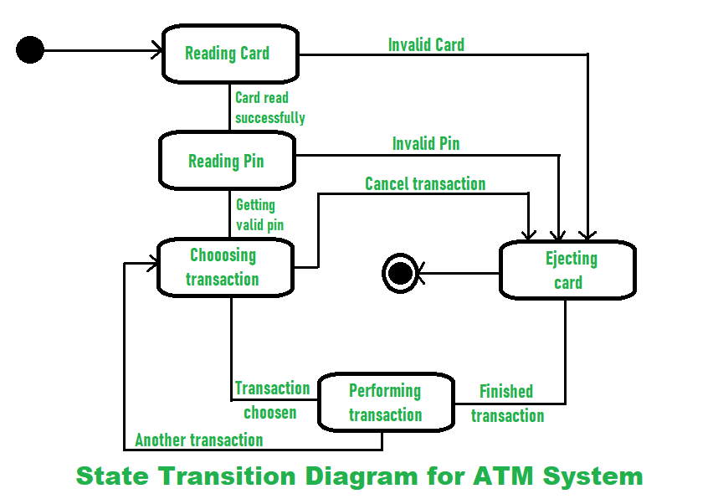
States and Transitions
- Initial State → Reading Card
  - The system starts in the initial state.
  - Transition to Reading Card when a card is inserted.
- Reading Card → Ejecting Card
  - If the card is Invalid, the system transitions to Ejecting Card.
- Reading Card → Reading Pin
  - If the card is read successfully, the system transitions to Reading Pin.
- Reading Pin → Ejecting Card
  - If the entered PIN is Invalid, transition to Ejecting Card.
- Reading Pin → Ejecting Card
  - If the user Cancels the transaction, transition to Ejecting Card.
- Reading Pin → Choosing Transaction
  - If the PIN is Valid, the system moves to Choosing Transaction.
- Choosing Transaction → Performing Transaction
  - When a Transaction is chosen, transition to Performing Transaction.
- Performing Transaction → Choosing Transaction
  - If the user wants to perform Another transaction, return to Choosing Transaction.
- Performing Transaction → Ejecting Card
  - When the Transaction is finished, the system transitions to Ejecting Card.
- Ejecting Card → Final State
- After the card is ejected, the system reaches the Final State.

Q7) How do you design test cases from Use Cases?
A)
Designing test cases from Use Cases is one of the most structured and widely used approaches in software testing. Since use cases describe how a user interacts with a system to achieve a goal, they provide an excellent foundation for deriving both functional and negative test cases. Below is a detailed explanation.

Step-by-Step Process for Designing Test Cases from Use Cases
1. Study the Use Case Document
- Read the complete use case to understand:
  - Actors (who interacts with the system)
  - Preconditions (system state before execution)
  - Triggers (events that start the use case)
  - Main Flow (Happy Path)
  - Alternate Flows (variations in the process)
  - Exception Flows (errors, invalid inputs, failure scenarios)
  - Postconditions (system state after execution)
- This helps identify all possible paths through the use case.

2. Identify Test Scenarios
- From each flow (basic, alternate, exception), derive scenarios:
  - Happy path scenario: The normal, expected flow (e.g., successful login).
  - Alternate scenarios: Valid variations (e.g., login with a different authentication method).
  - Exception scenarios: Invalid or error cases (e.g., wrong password, locked account).
- Each scenario will form the basis for one or more test cases.

3. Define Preconditions & Inputs
- Extract preconditions from the use case to ensure proper setup.
- Identify required inputs (data fields, credentials, amounts, etc.).
- Apply Equivalence Partitioning (EP) and Boundary Value Analysis (BVA) for data coverage.

4. Write Detailed Test Steps
- Convert each use case step into test case actions:
  - Actor actions → Test input steps
  - System responses → Expected results
- Ensure steps are clear, repeatable, and traceable back to the use case.

5. Define Expected Results
- For each step, write the system’s expected response.
- At the end, confirm the postconditions:
  - Success outcome (e.g., transaction completed, confirmation displayed).
  - Failure outcome (e.g., error message shown, transaction aborted).
6. Cover Alternate & Exception Flows
- For every alternate or exception flow in the use case:
  - Create separate test cases.
  - These serve as negative testing (invalid inputs, system constraints).
  - Example: Invalid PIN entered → ATM ejects card.

7. Add Test Data & Environment Details
- Specify test data (e.g., valid user ID, invalid PIN, account balance).
- Define environment setup (e.g., test database, mock services).
- Include any cleanup steps (e.g., rollback transactions after testing).

8. Assign Priority & Traceability
- Link each test case back to the use case ID for traceability.
- Assign priority:
  - High = critical business flows (main success scenario).
  - Medium/Low = alternate or less frequent scenarios.
- This ensures complete requirement coverage.

Structure of a Test Case from Use Case
A test case typically contains:
- Test Case ID (linked to Use Case ID)
- Title (descriptive name)
- Preconditions (setup state)
- Test Data (input values)
- Steps to Execute (actions based on use case flow)
- Expected Results (system responses + postconditions)
- Type (positive / negative / boundary / exception)
- Priority (criticality based on use case importance)

Example: ATM Withdrawal Use Case
- Actor: Customer
- Goal: Withdraw cash
- Precondition: Card is valid, account active
- Basic Flow: Insert card → Enter PIN → Select Withdraw → Enter amount → Dispense cash → Eject card
- Alternate Flow: Wrong PIN entered → Retry up to 3 times
- Exception Flow: Insufficient balance → Show error, eject card
Derived Test Cases
Test Case ID | Scenario | Preconditions | Steps | Expected Result
TC-ATM-001 | Happy Path Withdrawal | Valid card, PIN, balance ₹5000 | Insert card → Enter PIN → Select Withdraw ₹1000 → Confirm | ₹1000 dispensed, balance updated, card ejected
TC-ATM-002 | Invalid PIN (3 attempts) | Valid card | Insert card → Enter wrong PIN thrice | Show “Card blocked”, card ejected
TC-ATM-003 | Insufficient Balance | Balance ₹500 | Insert card → Enter PIN → Withdraw ₹1000 | Show “Insufficient funds”, no cash, card ejected
TC-ATM-004 | Cancel Transaction | Valid card, PIN | Insert card → Enter PIN → Select Cancel | Transaction aborted, card ejected

Q8) List and briefly describe the common states in a typical Defect Life Cycle.
A)
A Defect Life Cycle (Bug Life Cycle) is the process that a defect goes through during its lifetime — from the moment it is discovered until it is fixed and closed. It helps track and manage defects systematically. Below are the common states in a typical defect life cycle, explained in detail:
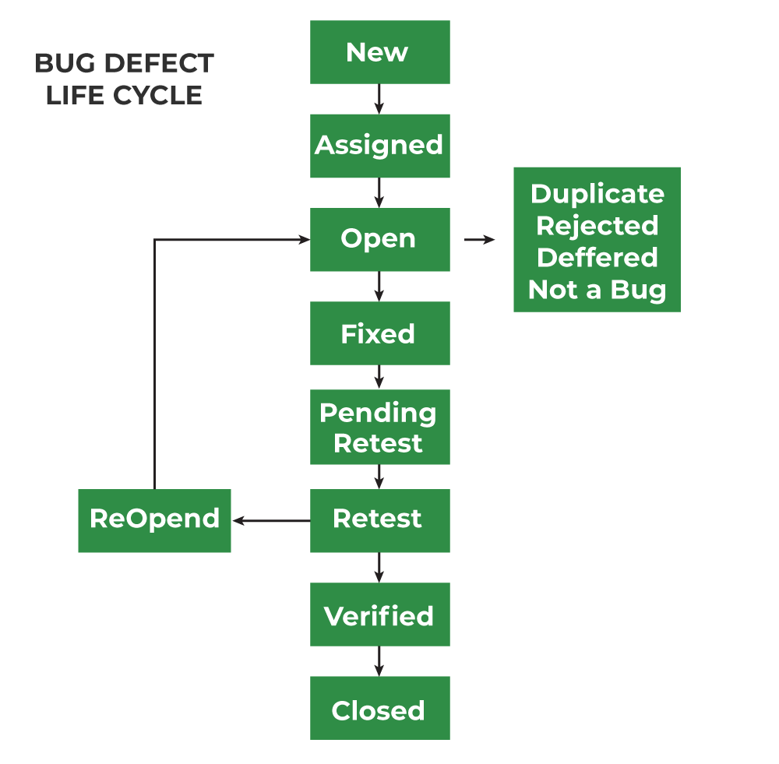
Common States in a Defect Life Cycle
- New / Opened
  - A tester finds a defect and logs it in the defect tracking system with details (steps to reproduce, screenshots, severity, priority).
  - Status = New.
  - The defect is waiting to be reviewed and assigned.

- Assigned
  - The defect is reviewed by the project manager/lead and assigned to a developer for fixing.
  - Status = Assigned.
  - Responsibility shifts to the developer.

- Open
  - The developer starts analyzing the defect.
  - Status = Open.
  - The developer will confirm whether the defect is valid and begin working on it.

- Rejected / Not a Bug
  - If the developer or lead finds the defect invalid (e.g., incorrect understanding of requirement, duplicate issue, or working as designed), the defect is marked as Rejected or Not a Bug.

- Deferred / Postponed
  - The defect is valid but fixing is delayed due to low priority, dependency, or planned for a future release.
  - Status = Deferred.

- Duplicate
  - If the defect is already reported in the system, it is marked as Duplicate and not worked on separately.

- In Progress / Fixing
  - Developer is actively working on the defect fix.
  - Status = In Progress (sometimes merged with Open).

- Fixed / Resolved
  - Developer applies the code fix and updates the status to Fixed or Resolved.
  - The defect is ready for retesting by QA.

- Retest
  - Tester verifies whether the fix works by re-executing the steps.
  - Status = Retest.
- Reopened
- If the defect still exists after retesting (fix failed), the tester reopens it.
- Status = Reopened → goes back to Assigned/Open state.

- Verified
- If the tester confirms that the defect is fixed properly, the status is updated to Verified.

- Closed
- Once the tester confirms the defect no longer exists and requirements are met, the defect is marked Closed.
- This is the final state of the defect.

Q9) List at least key features or functionalities typically found in a good Bug Tracking System
A)
Key Features of a Good Bug Tracking System
A Bug Tracking System (BTS) is designed to streamline the process of capturing, managing, and resolving defects during software development. Below are ten important features and their descriptions:
1. Bug Reporting and Logging
- Description: Enables testers, developers, or end users to report bugs with detailed information such as title, description, steps to reproduce, severity, priority, screenshots, environment details, and attachments.
- Why it matters: Ensures that developers have complete and clear information to replicate and fix the defect without confusion.

2. Workflow and Status Management
- Description: Supports the full Defect Life Cycle (e.g., New → Assigned → In Progress → Fixed → Retest → Closed) and allows customization of workflows as per the project’s needs.
- Why it matters: Helps track a defect from discovery to closure systematically and ensures no bug is left unresolved.

3. Prioritization and Severity Management
- Description: Provides fields to categorize defects by Severity (impact on system) and Priority (urgency of fixing).
- Why it matters: Allows teams to fix the most critical and urgent defects first, ensuring efficient use of time and resources.

4. Collaboration and Assignment
- Description: Allows bugs to be assigned to specific developers or teams, with options for adding watchers, comments, and notes. Some systems integrate with communication tools (e.g., Slack, Teams, email).
- Why it matters: Promotes better collaboration among testers, developers, and managers, reducing delays in fixing bugs.

5. Reporting and Dashboards
- Description: Provides visual dashboards, charts, and reports showing open vs. closed bugs, defect trends, resolution times, severity distribution, and workload distribution.
- Why it matters: Helps managers and QA leads track project health and identify bottlenecks in the defect management process.

6. Search and Filtering
- Description: Offers advanced search and filtering options to quickly locate bugs based on criteria such as status, severity, module, reporter, or assignee.
- Why it matters: Saves time and ensures that critical bugs can be found and reviewed without scrolling through long lists.

7. Integration with Other Tools
- Description: Integrates with project management tools (e.g., Jira, Trello), version control systems (e.g., Git), and CI/CD pipelines to enable end-to-end traceability.
- Why it matters: Streamlines development and testing workflows, ensuring smooth collaboration across teams.
8. Notifications and Alerts
- Description: Sends automatic updates via email, SMS, or in-app notifications whenever a bug’s status changes, is reassigned, or needs attention.
- Why it matters: Keeps all stakeholders updated in real time, reducing delays in communication and bug resolution.

9. Audit Trail and History Tracking
- Description: Maintains a record of all changes made to a defect — including updates to status, comments, attachments, and assignees.
- Why it matters: Provides transparency, accountability, and helps in analyzing the history of recurring issues.

10. Security and Access Control
- Description: Supports role-based access control (RBAC) so that testers, developers, and managers have appropriate permissions for viewing, editing, or closing bugs.
- Why it matters: Protects sensitive project information and ensures that only authorized users can make critical updates.

Q10) What is the difference between "Severity" and "Priority" in bug tracking?
A)
